

**content table**

|  |
| --- |
| **0.Introduction** |
| ***1.* Overview of TIC** |
| ***2.* Key Components of TIC** |
| ***3.* Google Services in TIC** |
| ***4.* Microsoft Tools in TIC** |
| ***5.* Challenges and Future Trends in TIC** |
| ***6.* Conclusion** |

**0.Introduction:**

1.1 Background of Information and Communication Technologies (TIC):

The background of Information and Communication Technologies (TIC) is rooted in the evolution of technology and its transformative impact on the way information is accessed, communicated, and processed. TIC represents a broad spectrum of technologies encompassing both hardware and software components that play a pivotal role in modern society.

* **Historical Context:**
  + Trace the origins of TIC back to the advent of computing and communication technologies.
  + Highlight key milestones in the development of TIC, such as the invention of the telegraph, telephone, and the emergence of early computing devices.
* **Convergence of Technologies:**
  + Discuss the convergence of information and communication technologies, emphasizing how the integration of computing, telecommunications, and networking has led to the interconnected digital landscape we experience today.

1.2 Purpose of the Report:

The purpose of this report is to comprehensively examine the landscape of Information and Communication Technologies (TIC) and associated technologies, shedding light on their significance, applications, and impact on various facets of contemporary society. The report aims to fulfill the following objectives:

* **Understanding TIC in a Global Context:**
  + Provide a detailed understanding of Information and Communication Technologies on a global scale.
  + Explore how TIC has become an integral part of the interconnected world, influencing diverse sectors and contributing to the digital transformation of societies.
* **Examination of Key Components of TIC:**
  + Analyze the key components that constitute TIC, including hardware, software, networking infrastructure, and services.
  + Highlight the role of these components in shaping the functionality and capabilities of TIC.
* **In-Depth Exploration of Selected Technologies:**
  + Investigate specific technologies that play a pivotal role in the TIC landscape, with a focus on Google services, Microsoft tools, Git, and GitHub.
  + Explore how these technologies contribute to collaboration, development, and communication within the digital ecosystem.
* **Security and Privacy Considerations:**
  + Address the critical aspects of security and privacy within the realm of TIC.
  + Examine the measures and best practices employed to safeguard data, systems, and communication channels.
* **Identification of Challenges and Future Trends:**
  + Identify and analyze the challenges faced by TIC, ranging from cybersecurity threats to issues of inclusivity.

**1.Overview of TIC:**

1.1Importance in the Modern Era:

In the modern era, Information and Communication Technologies (TIC) have become indispensable, permeating virtually every aspect of our personal and professional lives. The importance of TIC in the contemporary landscape is multifaceted, influencing societal, economic, and technological domains. This section delves into the key reasons why TIC holds paramount significance in the present era.

* **Enabler of Global Connectivity:**
  + **Communication Across Borders:** TIC facilitates seamless communication across geographical boundaries, connecting individuals, businesses, and governments on a global scale.
  + **Cross-Cultural Collaboration:** It promotes cross-cultural collaboration, fostering innovation and knowledge exchange among diverse communities.
* **Catalyst for Economic Growth:**
  + **Digital Economy:** TIC forms the backbone of the digital economy, driving innovation, entrepreneurship, and economic growth.
  + **E-Commerce:** It enables the growth of e-commerce, providing new avenues for businesses to reach consumers and streamline transactions.
* **Transformation of Industries:**
  + **Digital Transformation:** TIC underpins the ongoing digital transformation of industries, revolutionizing traditional processes and business models.
  + **Industry 4.0:** It plays a pivotal role in Industry 4.0, incorporating technologies like IoT, AI, and automation for enhanced efficiency and productivity.
* **Information Access and Knowledge Dissemination:**
  + **Ubiquitous Access to Information:** TIC ensures ubiquitous access to information, empowering individuals with knowledge and resources.
  + **E-Learning Platforms:** It supports e-learning platforms, revolutionizing education by making educational resources accessible to a global audience.

**2. Key Components of TIC:**

1.1Hardware:

The hardware component of Information and Communication Technologies (TIC) comprises the physical devices and equipment that form the foundation for computing, communication, and information processing. These hardware components play a crucial role in the functionality and performance of TIC systems. This section provides an overview of the key hardware components within the TIC ecosystem.

1.2Software:

In Information and Communication Technologies (TIC), software plays a pivotal role in facilitating communication, processing information, and enabling various applications. This section explores the diverse categories of software that contribute to the functionality and efficiency of TIC systems.

* **Operating Systems:**
  + **Windows, macOS, Linux:** These are examples of general-purpose operating systems that manage hardware resources, provide user interfaces, and support software applications.
  + 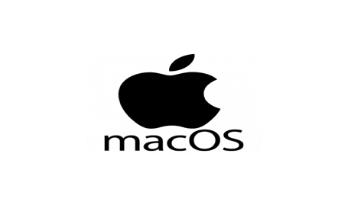
  + **Mobile Operating Systems (iOS, Android):** Designed for smartphones and tablets, mobile operating systems optimize performance and support app ecosystems.

**3.Google Services in TIC:**

1.1Google Workspace (formerly G Suite):

**Google Workspace (formerly G Suite)**

Google Workspace, formerly known as G Suite, is a comprehensive suite of cloud-based collaboration and productivity tools developed by Google. It encompasses a set of applications that facilitate communication, document creation, collaboration, and information sharing among individuals and organizations. Google Workspace is designed to enhance efficiency, promote collaboration, and streamline workflows. As of my last knowledge update in January 2022, here is an overview of the key components of Google Workspace:

* **Gmail:**
  + **Purpose:** Email communication and management.
  + **Features:** Custom email addresses, spam filtering, and integration with other Google Workspace apps.
  + 

1.2 AI and Machine Learning Services:

AI (Artificial Intelligence) and Machine Learning services have become integral components of Information and Communication Technologies (TIC), offering advanced capabilities for data analysis, pattern recognition, and decision-making. Here's an overview of some prominent AI and Machine Learning services:

* Amazon Web Services (AWS) AI/ML Services:
  + **Amazon SageMaker:** A fully-managed service for building, training, and deploying machine learning models.
  + **Amazon Comprehend:** Natural language processing (NLP) service for extracting insights and sentiment analysis from text.
  + **Amazon Rekognition:** Image and video analysis service for object and scene detection, facial analysis, and content moderation.

**4.Microsoft Tools in TIC:**

Microsoft provides a suite of tools and services that play a crucial role in Information and Communication Technologies (TIC). These tools cover a wide range of applications, from productivity and collaboration to development and cloud services. Here is an overview of key Microsoft tools within the TIC ecosystem:

* **Microsoft 365:**
  + **Purpose:** Cloud-based suite that combines productivity tools for communication, collaboration, and document creation.

Azure Cloud Services:

* **Purpose:** Microsoft's cloud computing platform providing a wide range of services for building, deploying, and managing applications.

**Visual Studio:**

* **Purpose:** Integrated development environment (IDE) for building, debugging, and deploying applications.
* 

**Power Platform:**

* **Purpose:** Suite of tools for building custom applications, automating workflows, and analyzing data.
* **PowerShell:**
  + **Purpose:** Command-line shell and scripting language for task automation and configuration management.
  + **Use Cases:**
    - **Scripting:** Automates repetitive tasks.
    - **Configuration Management:** Manages system configurations.
* **Microsoft Endpoint Manager:**
  + **Purpose:** Unified management platform for securing and managing devices and applications.
  + **Components:**
    - **Microsoft Intune:** Cloud-based service for device management.
    - **Configuration Manager:** On-premises solution for managing devices and applications.
    - 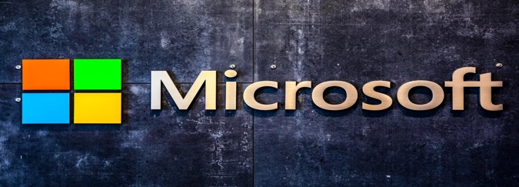

***5.* Challenges and Future Trends in TIC:**

As Information and Communication Technologies (TIC) continue to evolve, various challenges emerge while new trends shape the landscape. Addressing these challenges and staying abreast of emerging trends are crucial for organizations and individuals involved in TIC. Here's an exploration of challenges and future trends in TIC:

**Challenges:**

* **Cybersecurity Threats:**
  + *Challenge:* The constant evolution of cyber threats poses a significant challenge to the security of TIC systems.
  + *Impact:* Data breaches, privacy concerns, and financial losses.
* **Digital Inequality:**
  + *Challenge:* Disparities in access to TIC resources, known as the digital divide, hinder equal opportunities for education and economic participation.
  + *Impact:* Limited access to information, education, and employment opportunities for underserved communities.
* **Data Privacy and Regulation:**
  + *Challenge:* Stricter regulations and increased awareness around data privacy require organizations to navigate complex compliance landscapes.
  + *Impact:* Non-compliance risks, legal consequences, and erosion of user trust.
* **Technological Obsolescence:**
  + *Challenge:* Rapid technological advancements may lead to the obsolescence of existing TIC infrastructure and tools.
  + *Impact:* Increased costs for upgrades, potential disruptions, and compatibility issues.
  + 
* **Interoperability and Standards:**
  + *Challenge:* Lack of standardized protocols and interoperability between different TIC systems can impede seamless communication and integration.
  + *Impact:* Inefficient data exchange, integration challenges, and limited scalability.
* **Ethical Considerations in AI:**
  + *Challenge:* Ensuring responsible and ethical use of AI technologies raises complex questions around bias, transparency, and accountability.
  + *Impact:* Potential misuse of AI, ethical controversies, and damage to organizational reputation.

**Future Trends:**

* **5G Technology:**
  + *Trend:* The widespread adoption of 5G technology promises faster and more reliable communication, enabling new applications such as augmented reality (AR) and the Internet of Things (IoT).
* **Edge Computing:**
  + *Trend:* The rise of edge computing involves processing data closer to the source, reducing latency and enhancing real-time capabilities, critical for applications like IoT.
* **Artificial Intelligence and Machine Learning Integration:**
  + *Trend:* Increased integration of AI and machine learning across various TIC applications, improving automation, data analysis, and decision-making.
* **Quantum Computing:**
  + *Trend:* Advances in quantum computing have the potential to revolutionize computational power, solving complex problems that traditional computers struggle with.

Navigating these challenges and embracing future trends requires a proactive approach to innovation, collaboration, and adaptation. Organizations that strategically address these dynamics are better positioned to leverage the full potential of TIC for their growth and success.

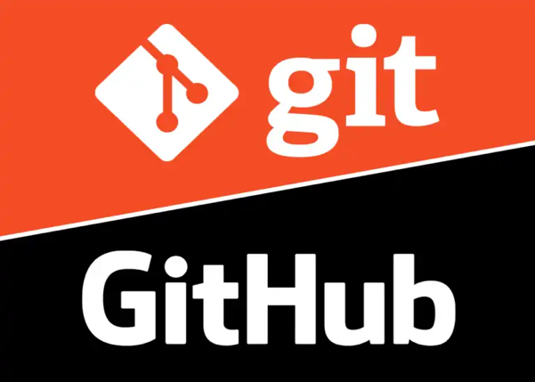

***6.* Conclusion:**

In conclusion, Information and Communication Technologies (TIC) have transformed the way we live, work, and connect with the world. This report has explored the diverse facets of TIC, ranging from its historical evolution to the key components that constitute its infrastructure. We delved into the significance of TIC in the modern era, emphasizing its role as a catalyst for global connectivity, economic growth, and innovation.

The report provided insights into the hardware and software components that form the backbone of TIC, highlighting their critical contributions to the functionality and efficiency of digital systems. Key Microsoft tools and services, as well as AI and Machine Learning offerings, were outlined, showcasing the richness of options available for individuals and organizations in the TIC landscape.

Challenges in TIC, including cybersecurity threats, digital inequality, and ethical considerations, were identified, underscoring the importance of addressing these issues to ensure responsible and equitable technological advancements. Additionally, future trends in TIC, such as 5G technology, edge computing, and quantum computing, were explored, signaling the exciting possibilities and advancements on the horizon.